Changes to CVAD wording in EMR:

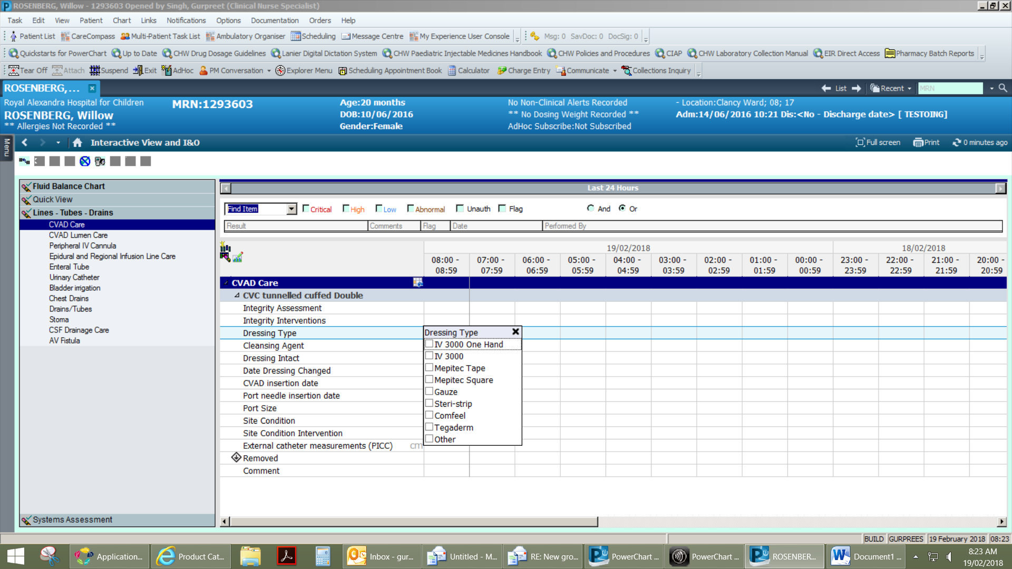

Add: Tegaderm IV advanced

Remove

Remove and add mepilex border

IV 3000 Standard

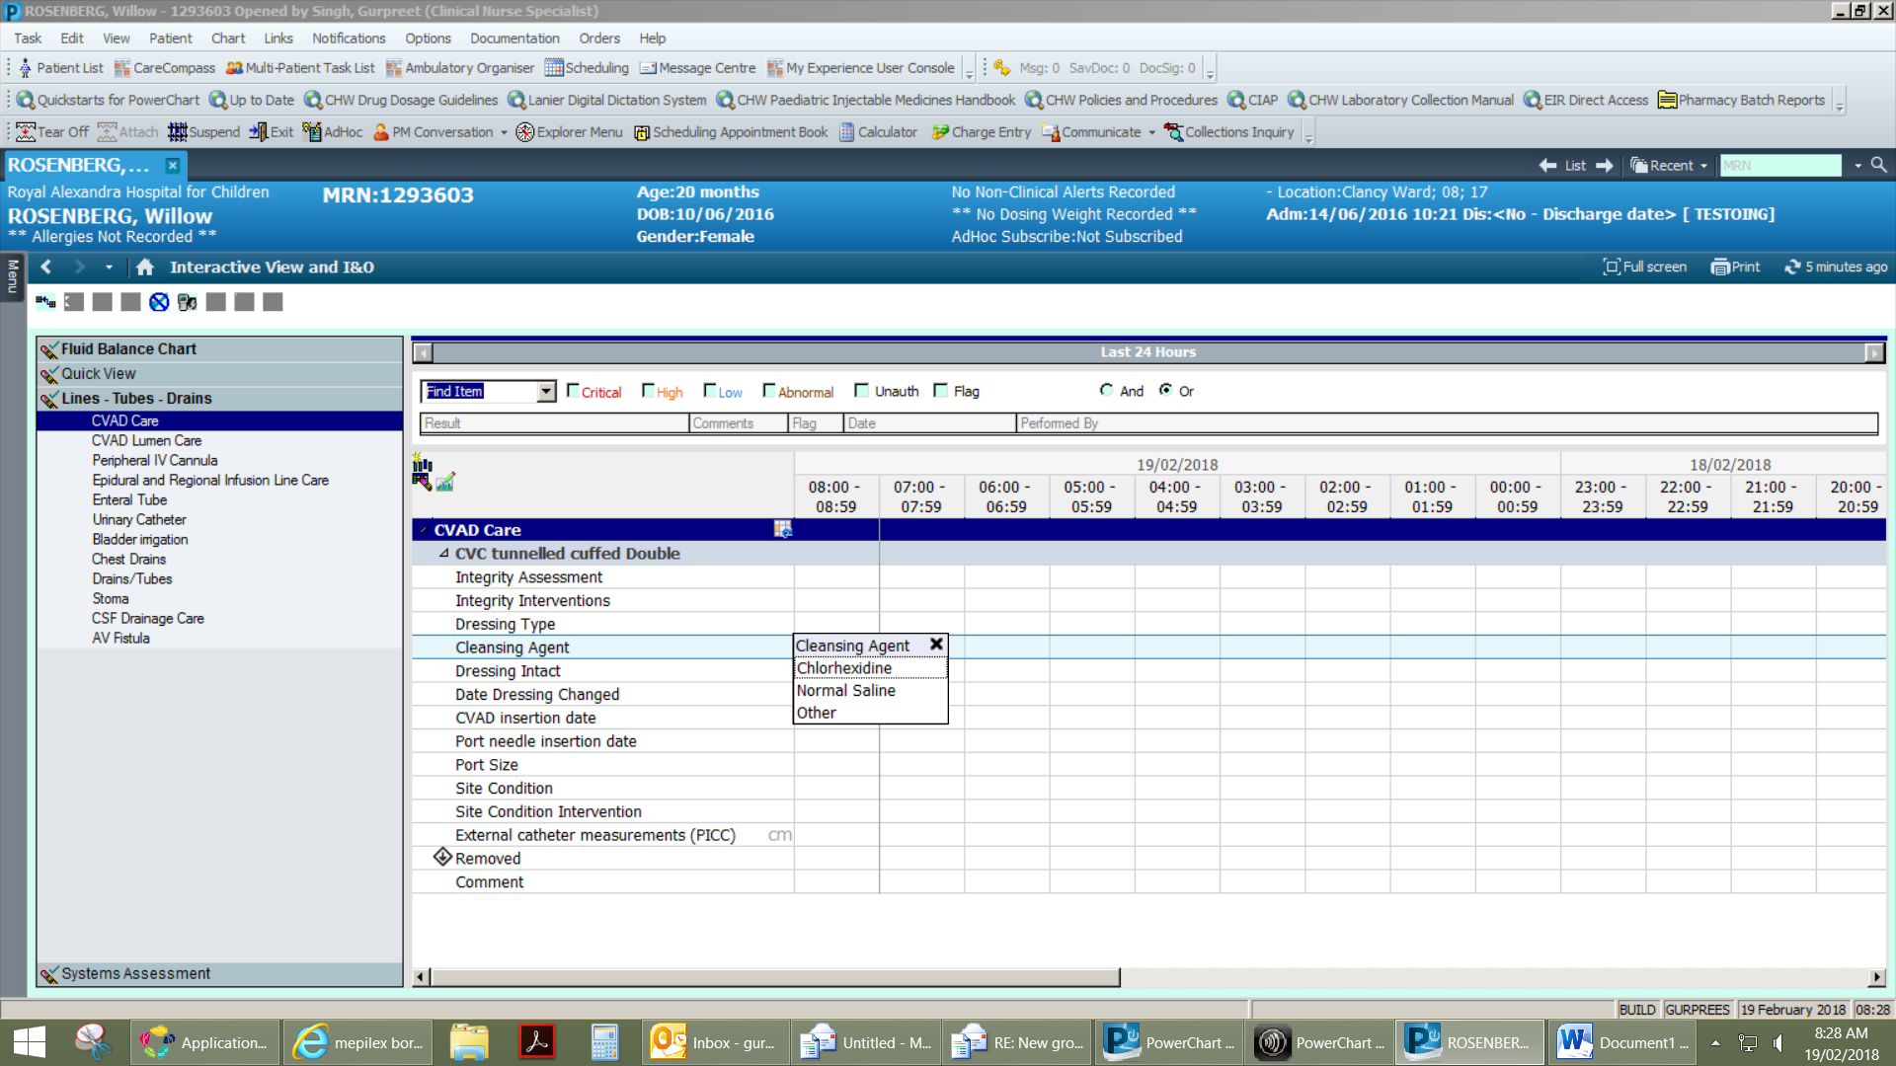

Change to: port needle size.

Options: ¾ inch

1 inch

1 ¼ inch

1 1/5 inch

other

0.9% Normal Saline

Change to: 2% Chlorhexidine in 70% Alcohol

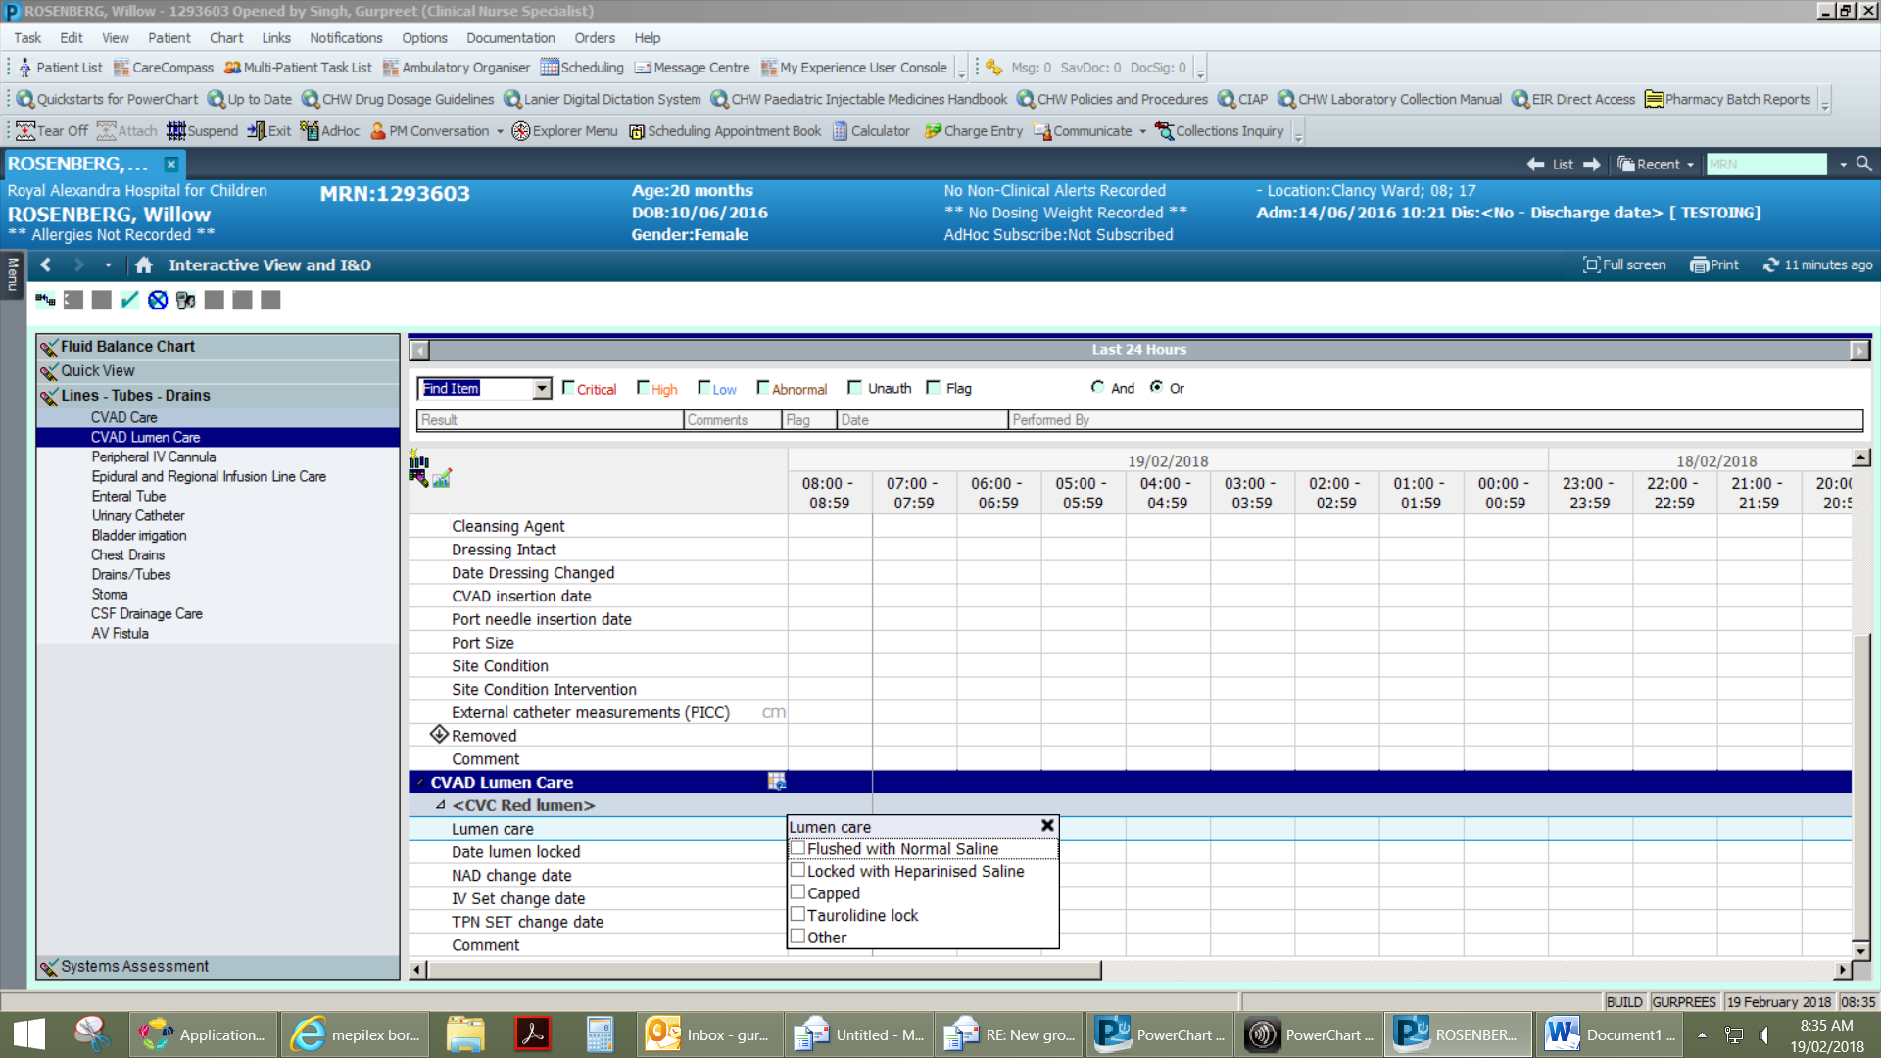

Remove